CardMaster2020 User Guide

Joao Lourenco - a21190948

ISEC – MSI – DAS 2015/2016

Notes:

This user guide is the part of DAS subject assignment. This document contains information on setting up our system and a detailed description how to play.

|  |  |  |  |  |
| --- | --- | --- | --- | --- |
| Version | Author | Reviewer | Date | Document Changes |
| 1.0 | J. Lourenco | TBD | 25/02/2015 | Initial draft |

Table of Contents

Welcome to CardMaster2020 4

CardMaster2020 User Guide 5

Interface Overview 6

Available Games 10

Hearts Game 10

Objective 10

Cards Values / Scoring 10

Deal 10

Play 11

Card Types 11

End of Turn Phase 11

Strategies 12

Blackjack 12

Objective 13

Cards Values / Scoring 13

Deal 13

Play 13

End of Turn Phase 13

Strategies 14

MultiPlayer Games 14

Credits 14

Glossary 14

Games Setup Example 15

References 15

# Welcome to CardMaster2020

This game gives you a chance to play all time cards games using an amazing and intuitive interface. Became an expert and play against the ultimate Artificial Intelligence engine. This instructions user guide will tell you everything you need to know to spend a great time in solo or multiplayer games. Challenge your friends, make teams, defeat the best AI engine available in the market. For more details, go online and check out our tutorial video at [www.isec.pt](http://www.isec.pt).

# 

# CardMaster2020 User Guide

This user guide is intended as a reference for all rules and games queries. This guide teaches players how to play the game. It includes a learn how to play session with all rules reference guide needed during the game.

# Interface Overview

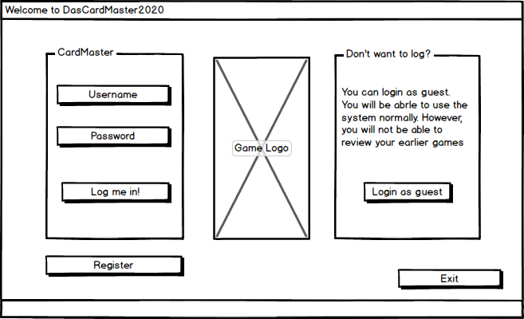

Figure 1 - Login

When you start your application several options are offered:  
Register as new user, Login (for existing users) and play available games as guest.

Playing games as user guest will not going to save their progress. However, all remaining functionalities are available.

Before pressing “Log me in!” button be sure that username and password are correct.

A register field is available to create new players only. After creating a new player data will start being recorded for each game played. User can check their progress for each game successfully played.

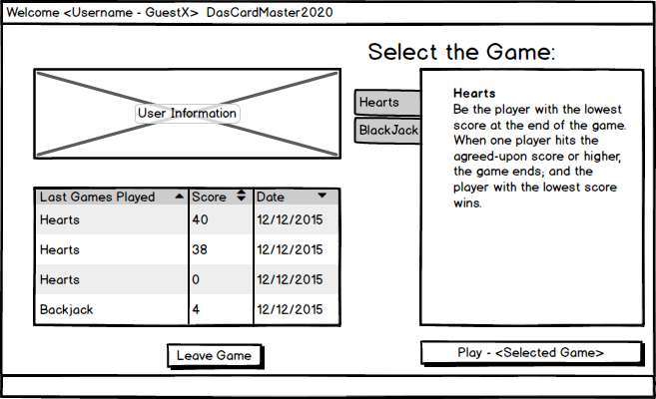

After adding your username and password user’s personal information is shown in the top left area (only available for users which log in was done successfully). All results for previous games are listed in the bottom left area.

Game selection is shown in the right panel. Select game tab and click on Play (selected game configuration is shown).

If user details are not correct the user can click on “Leave Game” button. Login menu will be shown.

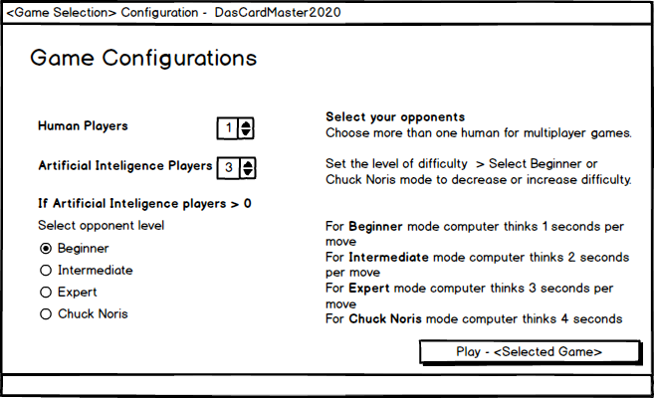

Different configuration settings may be presented according to related game. For solo games user will not be offered any option to add human or automated players.

Select the number of human an non human players you would like to play against.

A group of default configurations is added for each game.

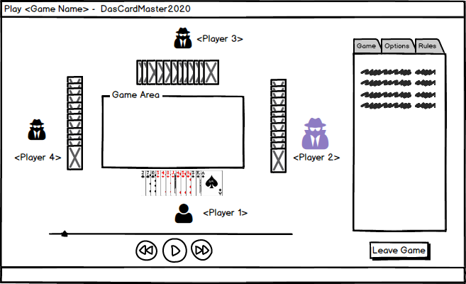

After confirm some configuration details you can start playing. In the right panel information related to Game (statistics), Options or Rules is shown in the tab.

Player in blue is the one responsible to start playing.

In the bottom a timeline is shown. This allow users to move backward and forward (up to present) to check which cards were played.

If user decides to leave the game before it is completed (clicking on Leave Game button), progress for human users will not be saved. Only completed games are saved and stored for later records.

# Available Games

There are two games available for dasCardMaster2020 version 1.0

Available games are Hearts and Blackjack.

# Hearts Game

Game details were based on bicycle website. [2]

## Objective

The main objective it to be the player with the lowest score at the end of the game. The game ends when one player hits the agreed-upon score or higher. The winner is the player with the lowest score**.**

The first time you play, allow yourself at least 45 minutes. Once players are familiar with the cards, a game will typically take 15-20 minutes.

## Cards Values / Scoring

At the end of each hand, players count the number of hearts they have taken as well as the queen of spades, if applicable.

Points per card:

|  |  |
| --- | --- |
| Cards | Point Value |
| Each hearts card | 1 point (each) |
| Queen of hearts | 13 points |
| Non hearts cards | 0 points (each) |

## Deal

The cards are automatically dialed. Each player gets 13 cards.

## Play

The player holding the 2 of clubs after the pass is the one that starts playing.

Each player is enforced by DasCardMaster2020 to follow the suit if possible. If a player is void of the suit led, a card of any other suit may be discarded. However, if a player has no clubs when the first trick is led, a heart or the queen of spades cannot be discarded. The highest card of the suit led wins a trick and the winner of that trick leads next. There is no trump suit.

The winner of the trick collects it and places it face down. Hearts may not be led until a heart or the queen of spades has been discarded. The queen does not have to be discarded at the first opportunity.

The queen can be led at any time.

## Card Types

The cards in each suit rank from the ace (the highest) to the 2 (the lowest). There are no trumps.

## End of Turn Phase

The game is played to 100 points. When a player takes all 13 hearts and the queen of spades in one hand, instead of losing 13 points, that player scores zero and each of his opponents score an additional 13 points.

## Strategies

The queen of spades rules the game of Hearts. To ignore the queen is to court humiliation and risk defeat. Consideration of the queen should begin before play starts, during the passing phase. Any high spades (Q, K, A) are dangerous if they are not protected by several lower spades.

However, it can be fatal to be short on low cards in a particular suit, especially later in the game. Using the last example, say a few hands have passed, and you still have the 8, 10, queen, and king of clubs. After the ace and 9 are played, you happily throw down your queen, and the top player takes the trick with the ace.

However, the player to your right threw down the jack of clubs. You now have the three highest clubs (8, 10, K). What happens after that could be destructive. Players will be running out of clubs, and next time someone leads in clubs, they’ll paint you with hearts or stick you with the queen of spades.

Guarded high-cards should be saved until later in the game, especially if they are hearts. This will help to prevent someone from successfully Shooting the Moon. If the player who receives your discards likes to Shoot the Moon, you may wish to pass them a low heart. This may discourage them from making the attempt in the first place. [1]

# Blackjack

Game details were based on bicycle website. [2]

## Objective

Each participant attempts to beat the dealer by getting a count as close to 21 as possible, without going over 21.

## Cards Values / Scoring

It is up to each individual player if an ace is worth 1 or 11. Face cards are 10 and any other card is its pip value.

## Deal

System gives one card face up to each player in rotation clockwise, and then one card facing up to himself. Another round of cards is then dealt face up to each player, but the system takes his second card face down. Thus, each player except the dealer receives two cards face up, and the dealer receives one card face up and one card face down.

## Play

The player to the left goes first and must decide whether to "stand" or "hit". Thus, a player may stand on the two cards originally dealt him, or he may ask the System for additional cards, one at a time, until player either decides to stand on the total (if it is 21 or under), or goes "bust" and loses.

## End of Turn Phase

If the player goes bust, he has already lost his wager, even if the System goes bust as well. If the System goes over 21, he pays each player who has stood the amount of that player's bet. If the dealer stands at 21 or less, he pays the bet of any player having a higher total (not exceeding 21).

## Strategies

A "soft 17" (an ace and a 6), the total is 7 or 17. While a count of 17 is a good hand, the player may wish to draw for a higher total. If the draw creates a bust hand by counting the ace as an 11, the player simply counts the ace as a 1 and continues playing by standing or "hitting".

# MultiPlayer Games

(TBD)

# Credits

All credits go to Joao Lourenco

Student a21190948 at isec.pt

# Glossary

Active player – The player currently taking his turn is the active plauer.

Bust - If it is over 21.

Hand – Cards available to be played for each user.

Hit - Ask for another card in an attempt to get closer to a count of 21, or even hit 21 exactly.

Soft hand - The combination of an ace with a card other than a ten-card.

Stand - Not ask for another card.

# Games Setup Example

(TBD)

# References

[1] - <https://www.ok.gov/odmhsas/documents/Boehrer,%20Susan%20-%20Family%20Fun%20All%20Year%20Long.pdf>

[2] - <http://www.bicyclecards.com>